Technical Proposal Design, Develop and Operationalize the “Bridge to Bangladesh” Global Diaspora Engagement Platform
Project Type: Web Platform & Cross-Platform Mobile Application (iOS & Android)
Development Approach: Full-cycle, from scratch

1. Introduction & Understanding of Context
The Bridge to Bangladesh initiative aims to establish a trusted, secure, and scalable digital ecosystem that connects the global Bangladeshi diaspora with verified development actors, initiatives, and opportunities in Bangladesh. The platform will move beyond fragmented engagement by enabling structured collaboration, transparent giving, knowledge exchange, campaigns, events, and long-term community building.
Our understanding is to design and operationalize a future-ready platform that supports global diaspora engagement, impact-driven partnerships, and institutional governance while ensuring compliance with international data protection and accessibility standards.

2. Proposed Technical Approach
We propose a modular, API-driven, and cloud-native architecture that supports scalability, security, and future feature expansion. The platform will be developed using a mobile-first and accessibility-first mindset, ensuring a consistent experience across web and mobile applications.
The solution will be built as an integrated ecosystem consisting of:
- Public-facing engagement platform (Web & Mobile)
- Secure user and role-based access management
- Verified stakeholder ecosystem
- Moderated communication and community engagement
- Campaigns, events, and storytelling modules
- Donation-ready architecture with compliance safeguards
- Robust admin dashboard for governance, moderation, and analytics

3. Development Methodology
We will follow an Agile-Scrum based development methodology with clearly defined phases and iterative validation.
Phase 1: Discovery & Inception
- Stakeholder workshops (Oxfam Bangladesh, Oxfam UK, diaspora representatives)
- User persona development
- Functional & Non-Functional Requirement Specification
- System architecture and roadmap finalization
Phase 2: UX/UI Design
- Information architecture and user journey mapping
- Wireframes and interactive prototypes
- Accessibility (WCAG 2.1 AA) and mobile-first design
Phase 3: Platform Development
- Web platform development
- Cross-platform mobile app development (iOS & Android)
- API and backend services
- Admin dashboard and moderation tools
Phase 4: Testing & Quality Assurance
- Functional, security, and performance testing
- User acceptance testing (UAT)
Phase 5: Deployment & Operationalization
- Cloud deployment
- Monitoring and logging setup
- Staff training and documentation

4. Core Platform Features
4.1 User Registration & Role-Based Profiles
- Secure registration and authentication
- GDPR-compliant consent management
- Role-based profiles for diaspora users, local stakeholders, moderators, and administrators
4.2 Verified Local Stakeholder Listings
- Structured profile templates by category
- Verification and approval workflow
- Visible verified status
4.3 Discovery & Matchmaking
- Advanced search and filtering
- Interest-based matchmaking
- Save, follow, and express-interest mechanisms
4.4 Moderated Messaging & Community Engagement
- Secure in-platform messaging
- Content posting and commenting
- Admin moderation and safeguarding controls
4.5 Campaigns, Events & Storytelling
- Campaign landing pages
- Event and dialogue management
- Content hub for blogs, videos, and stories

5. System Architecture Diagram
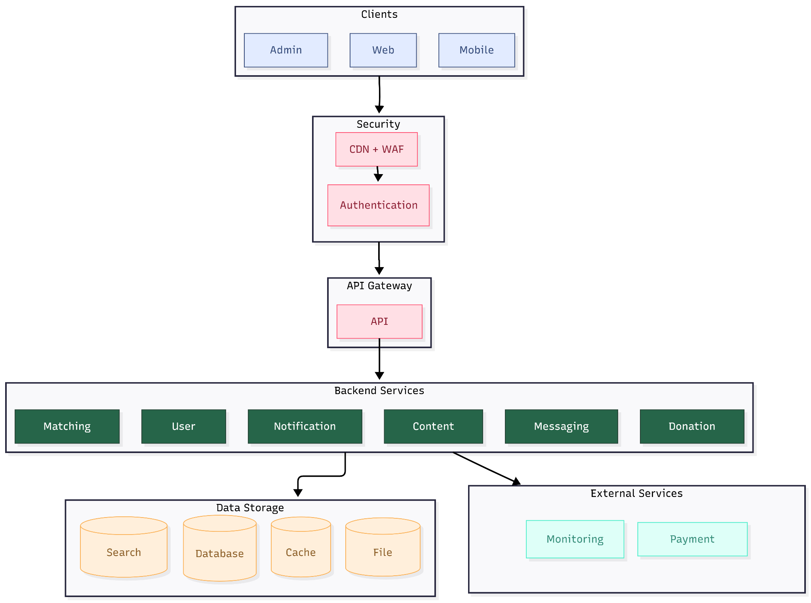

6. Donation & Compliance Readiness
The platform will be technically prepared for digital donations, including Zakat and Sadaqah, subject to regulatory approval. This includes:
- Donation flow architecture
- Fund categorization and acknowledgment logic
- API-ready payment gateway integration
- Financial transparency and audit-ready data structures
Activation of live financial transactions will only occur upon formal regulatory and organizational approval.

7. Admin Dashboard & Governance
A comprehensive admin dashboard will be developed to support:
- User and role management
- Content and community moderation
- Campaign and event management
- Analytics, reporting, and impact tracking
- Governance workflows and long-term operational oversight

8. Proposed Technical Stack
Frontend (Web): React / Next.js
Mobile Applications: Flutter (iOS & Android)
Backend: Node.js (NestJS) or Python (Django/FastAPI)
Database: PostgreSQL
API Layer: REST / GraphQL
Hosting & Infrastructure: AWS or Azure (Cloud-native)
Security: OWASP Top 10 compliance, role-based access control, encryption
Analytics: Custom dashboards with exportable reports

9. Testing and Quality Assurance
● Integration Testing: Applicant–Appointment–Tracking workflow
● Load Testing: Simulated peak traffic conditions
● Security Testing: Vulnerability Test
● UAT: Conducted with Oxfam Bangladesh before go-live
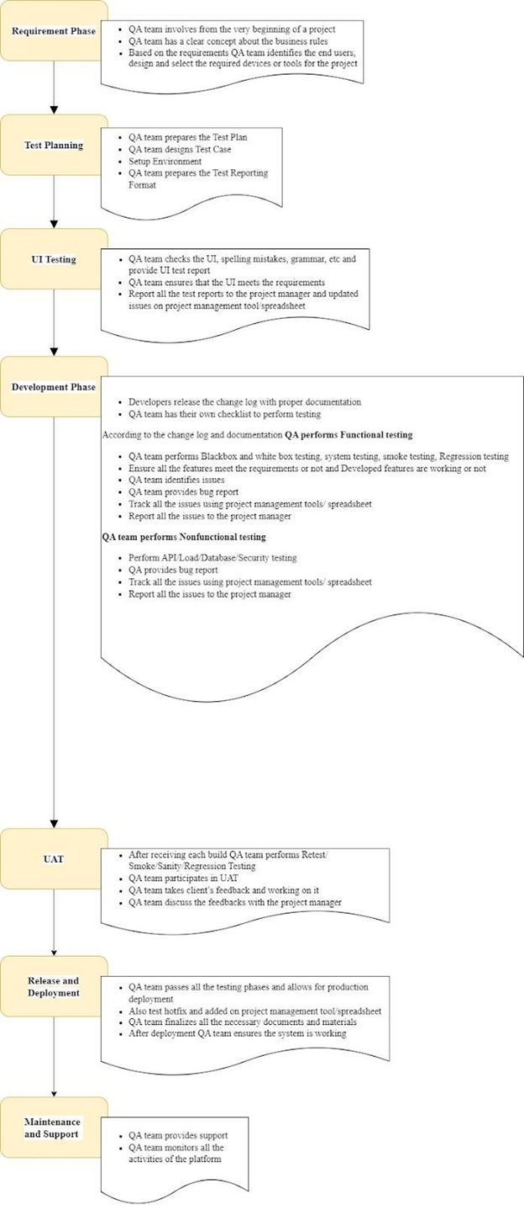

10. Deliverables
- Inception & System Requirement Report
- UX/UI Design Package
- Fully Functional Web Platform
- Cross-Platform Mobile Applications (iOS & Android)
- Admin Dashboard
- Donation-Ready Technical Architecture
- Analytics & Reporting Module
- Training, Documentation, and Knowledge Transfer
- Final Delivery & Handover Report

11. Sustainability & Scalability
The platform will be designed for long-term sustainability with modular architecture, clear governance workflows, and scalability for future geographic expansion, new engagement models, and evolving regulatory requirements.

12. Implementation Timeline
Overall Project Duration: 3 months

